**IF**

**--**

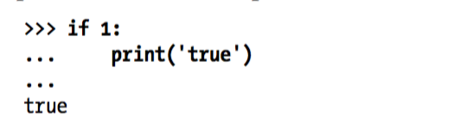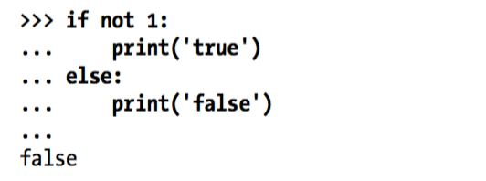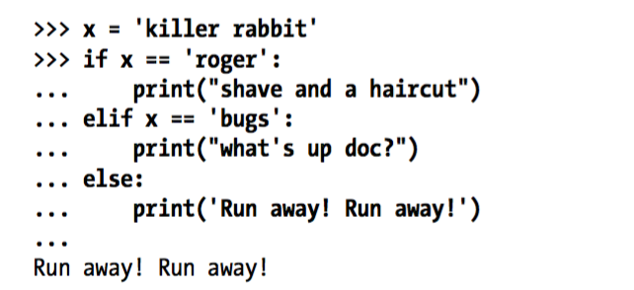

**WHILE**

**---------**

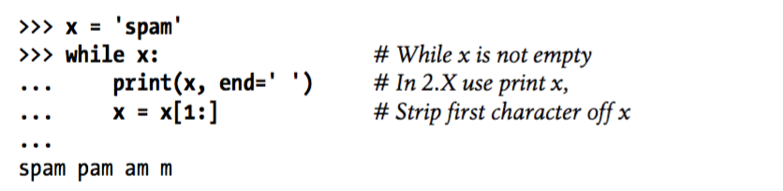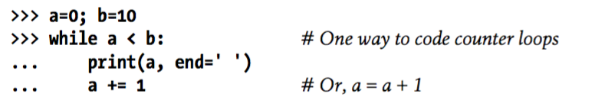



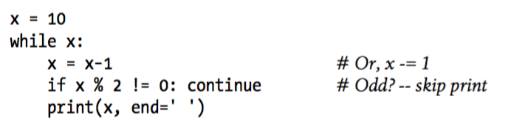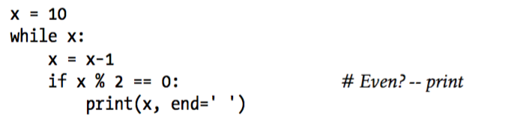



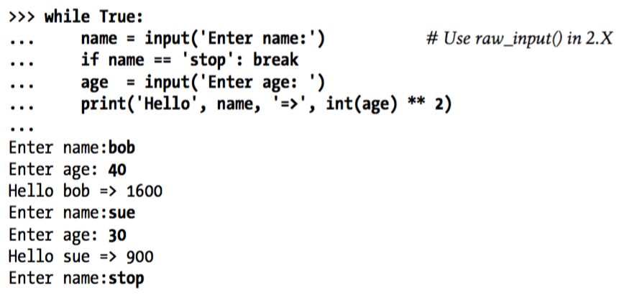



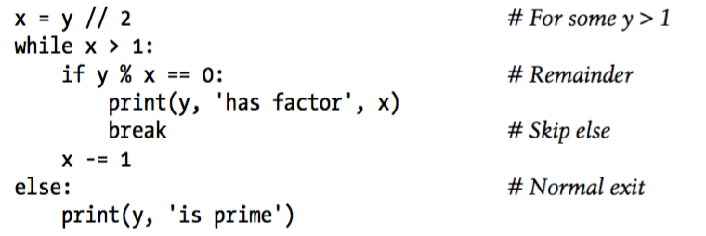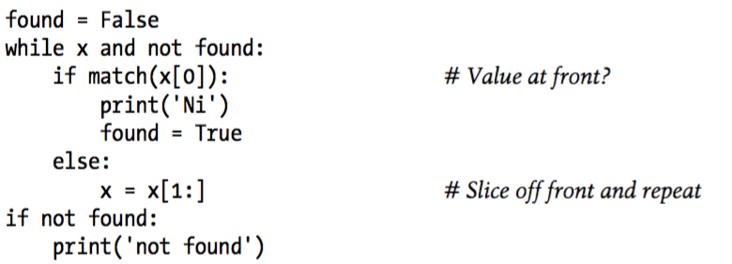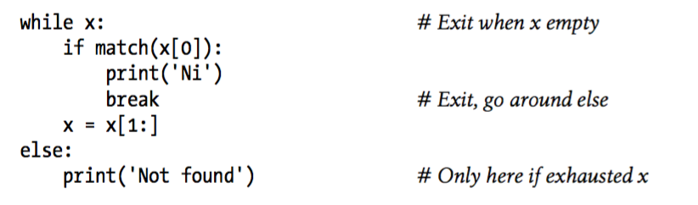

**FOR**

**------**

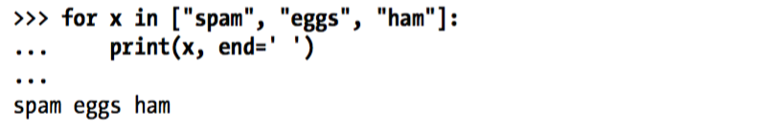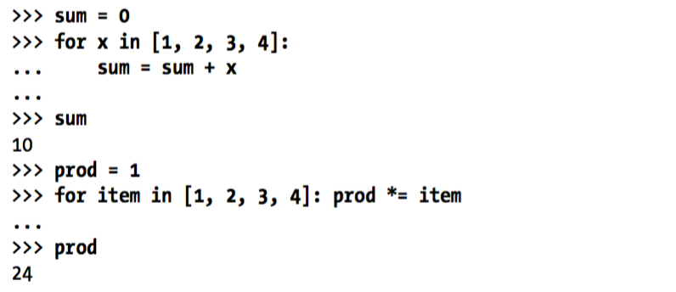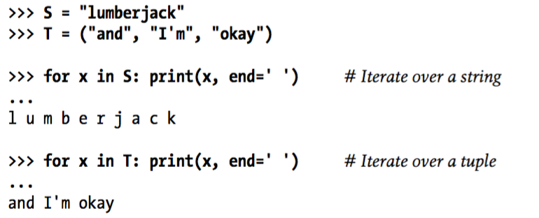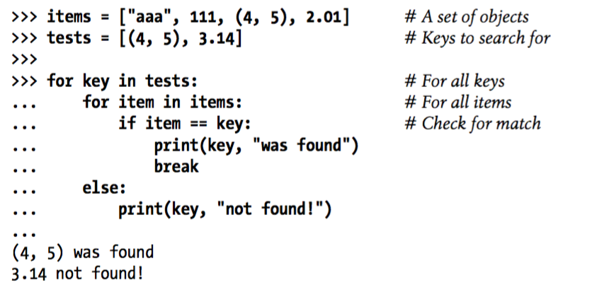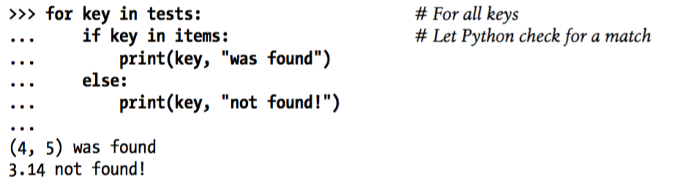

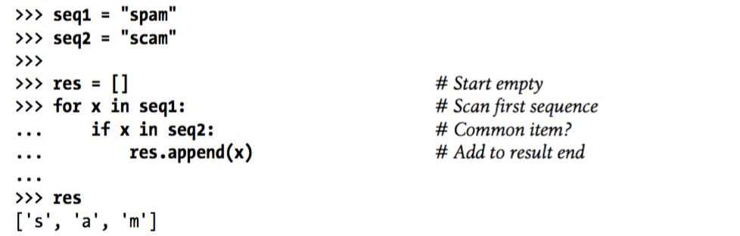

**List Comprehension -** collecting a results list with an iteration and optional filter test





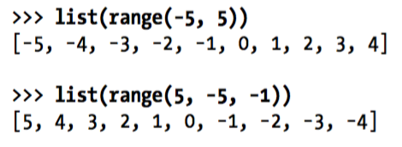

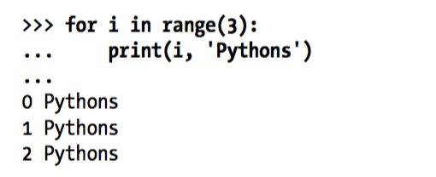

**The easiest and generally fastest way to step through a sequence exhaustively is always with a simple for, as Python handles most of the details for you.**

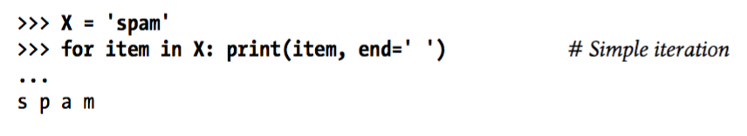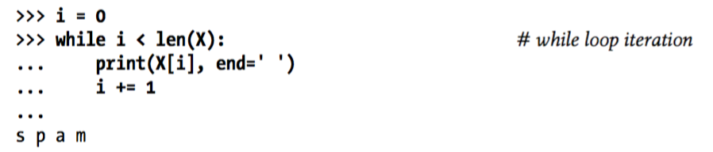

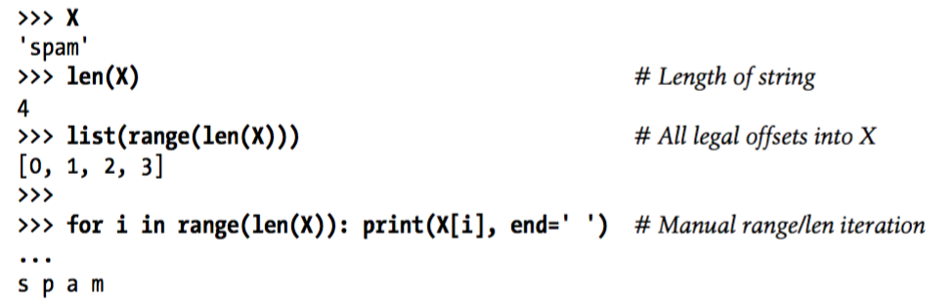

**As a general rule, use for instead of while whenever possible, and don’t use range calls in for loops except as a last resort.**

**Sometimes we want to manipulate indices.**

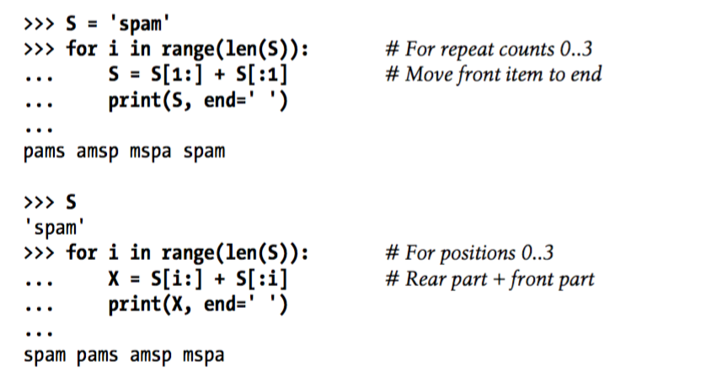

**Sometimes our searches are non exhaustive.**

**We can use range steps or slicing steps. Slicing is preferred.**

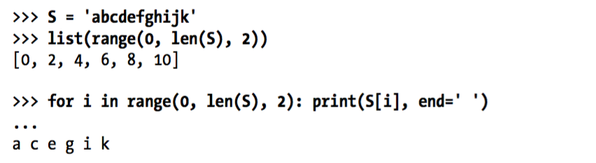

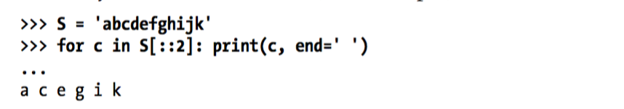

**Changing Lists.**

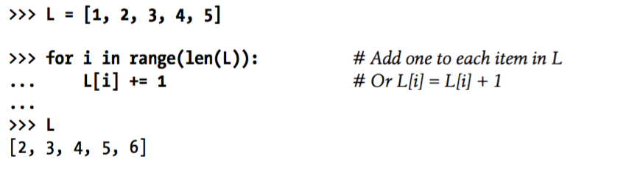

**Range works but list comprehensions are better.**



**Zip**

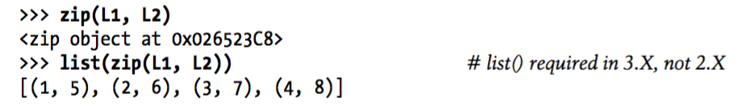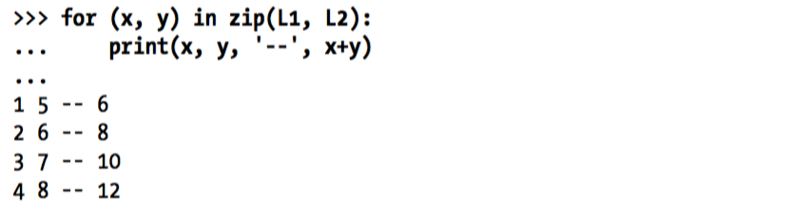

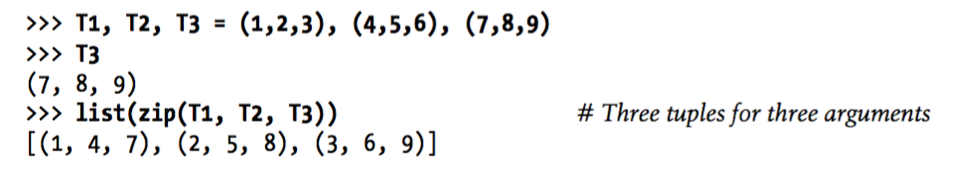

**zip truncates results tuples at length of the shortest sequence when the argument lengths differ.**

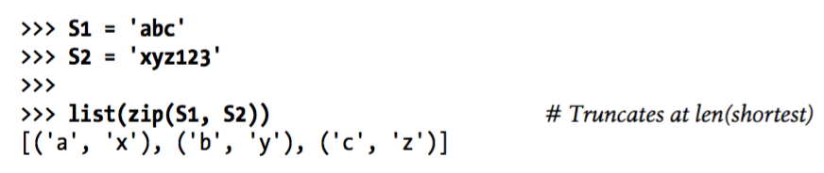

**Map**

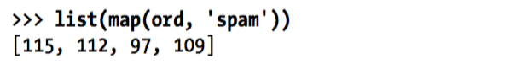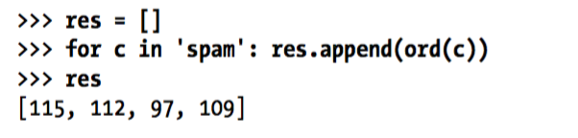

**Enumerate**

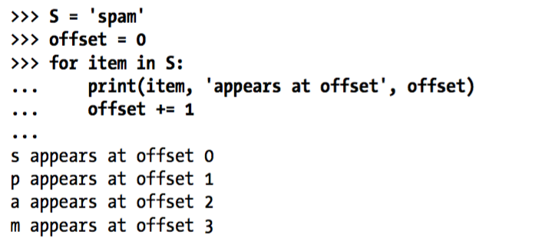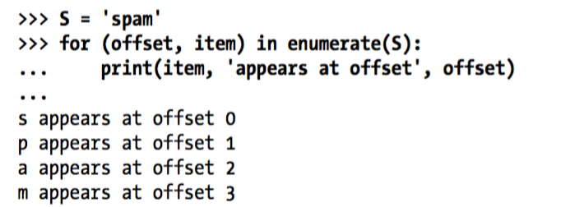

**The enumerate function returns a generator object—a kind of object that supports the iteration protocol. It has a method called by the next built-in function, which returns an (*index*, *value*) tuple each time through the loop. The for steps through these tuples automatically.**